Your temporary usage period for IBM SPSS Statistics will expire in 4981 days.

GET DATA
/TYPE=XLSX
/FILE='G:\My Drive\0Duy Research Master\Experiments\Exp 1_API\past result\SPSS work\Average time.xlsx'
/SHEET=name 'Average EslapsedTime'
/CELLRANGE=FULL
/READNAMES=ON
/DATATYPEMIN PERCENTAGE=95.0
/HIDDEN IGNORE=YES.
EXECUTE.
DATASET NAME DataSet1 WINDOW=FRONT.
* Chart Builder.
GGRAPH
/GRAPHDATASET NAME="graphdataset" VARIABLES=Hour MEAN(Average)[name="MEAN_Average"]
MISSING=LISTWISE REPORTMISSING=NO
/GRAPHSPEC SOURCE=INLINE.
BEGIN GPL
SOURCE: s=userSource(id("graphdataset"))
DATA: Hour=col(source(s), name("Hour"), unit.category())
DATA: MEAN_Average=col(source(s), name("MEAN_Average"))
GUIDE: axis(dim(1), label("Hour"))
GUIDE: axis(dim(2), label("Mean Average"))
GUIDE: text.title(label("Simple Bar Mean of Average by Hour"))
SCALE: linear(dim(2), include(0))
ELEMENT: interval(position(Hour*MEAN_Average), shape.interior(shape.square))
END GPL.

GGraph

Notes
Output Created |  | 12-MAY-2022 15:52:26
Comments
Input | Active Dataset | DataSet1
Input | Filter | <none>
Input | Weight | <none>
Input | Split File | <none>
Input | N of Rows in Working Data File | 13
Syntax |  | GGRAPH  /GRAPHDATASET NAME="graphdataset" VARIABLES=Hour MEAN(Average)[name="MEAN_Average"]  MISSING=LISTWISE REPORTMISSING=NO  /GRAPHSPEC SOURCE=INLINE.  BEGIN GPL  SOURCE: s=userSource(id("graphdataset"))  DATA: Hour=col(source(s), name("Hour"), unit.category())  DATA: MEAN_Average=col(source(s), name("MEAN_Average"))  GUIDE: axis(dim(1), label("Hour"))  GUIDE: axis(dim(2), label("Mean Average"))  GUIDE: text.title(label("Simple Bar Mean of Average by Hour"))  SCALE: linear(dim(2), include(0))  ELEMENT: interval(position(Hour*MEAN_Average), shape.interior(shape.square))  END GPL.
Resources | Processor Time | 00:00:00.94
Resources | Elapsed Time | 00:00:00.31

[DataSet1]

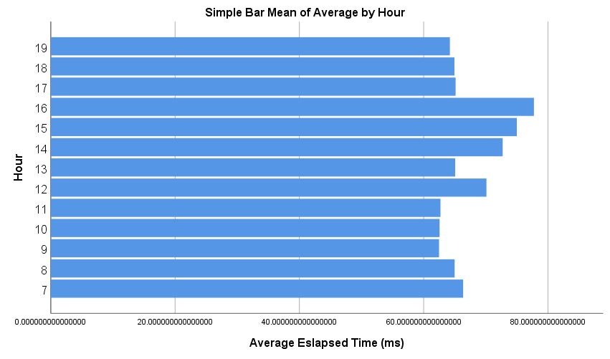

SAVE OUTFILE='G:\My Drive\0Duy Research Master\Experiments\Exp 1_API\past result\SPSS '+
'work\EXP1\AverageEslapsedTime.sav'
/COMPRESSED.
NEW FILE.
DATASET NAME DataSet2 WINDOW=FRONT.
DATASET ACTIVATE DataSet0.
DATASET CLOSE DataSet1.
DATASET ACTIVATE DataSet2.

GET DATA
/TYPE=XLSX
/FILE='G:\My Drive\0Duy Research Master\Experiments\Exp 1_API\past result\SPSS work\Average time.xlsx'
/SHEET=name '2022-5-11_7h08 to 19h08-12h'
/CELLRANGE=FULL
/READNAMES=ON
/DATATYPEMIN PERCENTAGE=95.0
/HIDDEN IGNORE=YES.
EXECUTE.
DATASET NAME DataSet3 WINDOW=FRONT.
* Chart Builder.
GGRAPH
/GRAPHDATASET NAME="graphdataset" VARIABLES=ElapsedTimeMilisecond MISSING=LISTWISE
REPORTMISSING=NO
/GRAPHSPEC SOURCE=INLINE.
BEGIN GPL
SOURCE: s=userSource(id("graphdataset"))
DATA: ElapsedTimeMilisecond=col(source(s), name("ElapsedTimeMilisecond"))
GUIDE: axis(dim(1), label("ElapsedTimeMilisecond"))
GUIDE: axis(dim(2), label("Frequency"))
GUIDE: text.title(label("Simple Histogram of ElapsedTimeMilisecond "))
ELEMENT: interval(position(summary.count(bin.rect(ElapsedTimeMilisecond))),
shape.interior(shape.square))
ELEMENT: line(position(density.normal(ElapsedTimeMilisecond)))
END GPL.

GGraph

Notes
Output Created |  | 12-MAY-2022 16:00:13
Comments
Input | Active Dataset | DataSet3
Input | Filter | <none>
Input | Weight | <none>
Input | Split File | <none>
Input | N of Rows in Working Data File | 39769
Syntax |  | GGRAPH  /GRAPHDATASET NAME="graphdataset" VARIABLES=ElapsedTimeMilisecond MISSING=LISTWISE  REPORTMISSING=NO  /GRAPHSPEC SOURCE=INLINE.  BEGIN GPL  SOURCE: s=userSource(id("graphdataset"))  DATA: ElapsedTimeMilisecond=col(source(s), name("ElapsedTimeMilisecond"))  GUIDE: axis(dim(1), label("ElapsedTimeMilisecond"))  GUIDE: axis(dim(2), label("Frequency"))  GUIDE: text.title(label("Simple Histogram of ElapsedTimeMilisecond "))  ELEMENT: interval(position(summary.count(bin.rect(ElapsedTimeMilisecond))),  shape.interior(shape.square))  ELEMENT: line(position(density.normal(ElapsedTimeMilisecond)))  END GPL.
Resources | Processor Time | 00:00:00.19
Resources | Elapsed Time | 00:00:00.19

[DataSet3]

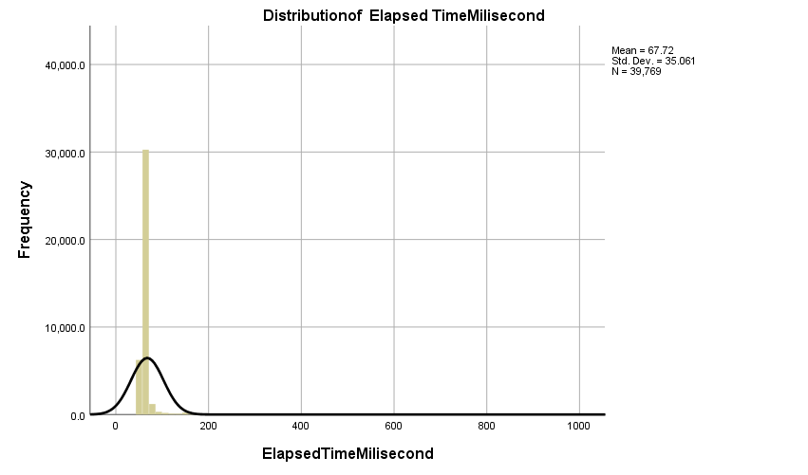

* Chart Builder.
GGRAPH
/GRAPHDATASET NAME="graphdataset" VARIABLES=ElapsedTimeMilisecond MISSING=LISTWISE
REPORTMISSING=NO
/GRAPHSPEC SOURCE=INLINE.
BEGIN GPL
SOURCE: s=userSource(id("graphdataset"))
DATA: ElapsedTimeMilisecond=col(source(s), name("ElapsedTimeMilisecond"))
GUIDE: axis(dim(1), label("Elapsed Time Milisecond"))
GUIDE: axis(dim(2), label("Frequency"))
GUIDE: text.title(label("Simple Histogram of ElapsedTimeMilisecond "))
ELEMENT: interval(position(summary.count(bin.rect(ElapsedTimeMilisecond))),
shape.interior(shape.square))
ELEMENT: line(position(density.normal(ElapsedTimeMilisecond)))
END GPL.

GGraph

Notes
Output Created |  | 12-MAY-2022 16:02:47
Comments
Input | Active Dataset | DataSet3
Input | Filter | <none>
Input | Weight | <none>
Input | Split File | <none>
Input | N of Rows in Working Data File | 39769
Syntax |  | GGRAPH  /GRAPHDATASET NAME="graphdataset" VARIABLES=ElapsedTimeMilisecond MISSING=LISTWISE  REPORTMISSING=NO  /GRAPHSPEC SOURCE=INLINE.  BEGIN GPL  SOURCE: s=userSource(id("graphdataset"))  DATA: ElapsedTimeMilisecond=col(source(s), name("ElapsedTimeMilisecond"))  GUIDE: axis(dim(1), label("Elapsed Time Milisecond"))  GUIDE: axis(dim(2), label("Frequency"))  GUIDE: text.title(label("Simple Histogram of ElapsedTimeMilisecond "))  ELEMENT: interval(position(summary.count(bin.rect(ElapsedTimeMilisecond))),  shape.interior(shape.square))  ELEMENT: line(position(density.normal(ElapsedTimeMilisecond)))  END GPL.
Resources | Processor Time | 00:00:00.22
Resources | Elapsed Time | 00:00:00.19

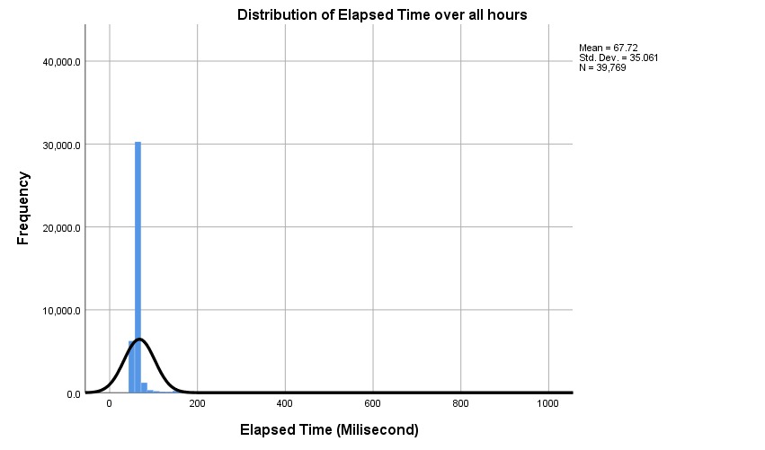

DATASET ACTIVATE DataSet0.
GET
FILE='G:\My Drive\0Duy Research Master\Experiments\Exp 1_API\past result\SPSS work\EXP1\AverageEslapsedTime.sav'.
DATASET NAME DataSet4 WINDOW=FRONT.
DATASET ACTIVATE DataSet3.

SAVE OUTFILE='G:\My Drive\0Duy Research Master\Experiments\Exp 1_API\past result\SPSS '+
'work\EXP1\All hours.sav'
/COMPRESSED.
DATASET ACTIVATE DataSet4.
* Chart Builder.
GGRAPH
/GRAPHDATASET NAME="graphdataset" VARIABLES=Hour
MEAN(AverageEslapsedTime)[name="MEAN_AverageEslapsedTime"] MISSING=LISTWISE REPORTMISSING=NO
/GRAPHSPEC SOURCE=INLINE.
BEGIN GPL
SOURCE: s=userSource(id("graphdataset"))
DATA: Hour=col(source(s), name("Hour"), unit.category())
DATA: MEAN_AverageEslapsedTime=col(source(s), name("MEAN_AverageEslapsedTime"))
GUIDE: axis(dim(1), label("Hour"))
GUIDE: axis(dim(2), label("Mean AverageEslapsedTime"))
GUIDE: text.title(label("Simple Bar Mean of AverageEslapsedTime by Hour"))
SCALE: linear(dim(2), include(0))
ELEMENT: interval(position(Hour*MEAN_AverageEslapsedTime), shape.interior(shape.square))
END GPL.

GGraph

Notes
Output Created |  | 12-MAY-2022 16:14:55
Comments
Input | Data | G:\My Drive\0Duy Research Master\Experiments\Exp 1_API\past result\SPSS work\EXP1\AverageEslapsedTime.sav
Input | Active Dataset | DataSet4
Input | Filter | <none>
Input | Weight | <none>
Input | Split File | <none>
Input | N of Rows in Working Data File | 13
Syntax |  | GGRAPH  /GRAPHDATASET NAME="graphdataset" VARIABLES=Hour  MEAN(AverageEslapsedTime)[name="MEAN_AverageEslapsedTime"] MISSING=LISTWISE REPORTMISSING=NO  /GRAPHSPEC SOURCE=INLINE.  BEGIN GPL  SOURCE: s=userSource(id("graphdataset"))  DATA: Hour=col(source(s), name("Hour"), unit.category())  DATA: MEAN_AverageEslapsedTime=col(source(s), name("MEAN_AverageEslapsedTime"))  GUIDE: axis(dim(1), label("Hour"))  GUIDE: axis(dim(2), label("Mean AverageEslapsedTime"))  GUIDE: text.title(label("Simple Bar Mean of AverageEslapsedTime by Hour"))  SCALE: linear(dim(2), include(0))  ELEMENT: interval(position(Hour*MEAN_AverageEslapsedTime), shape.interior(shape.square))  END GPL.
Resources | Processor Time | 00:00:00.09
Resources | Elapsed Time | 00:00:00.12

[DataSet4] G:\My Drive\0Duy Research Master\Experiments\Exp 1_API\past result\SPSS work\EXP1\AverageEslapsedTime.sav

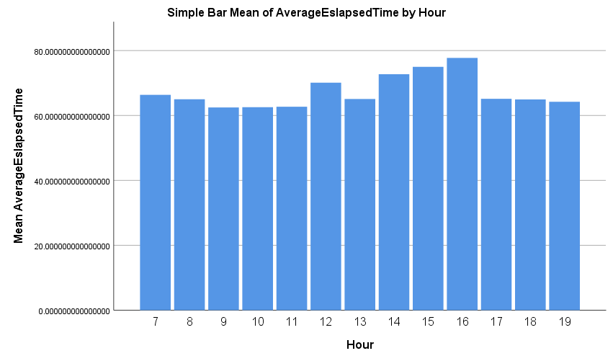

* Chart Builder.
GGRAPH
/GRAPHDATASET NAME="graphdataset" VARIABLES=Hour
MEAN(AverageEslapsedTime)[name="MEAN_AverageEslapsedTime"] MISSING=LISTWISE REPORTMISSING=NO
/GRAPHSPEC SOURCE=INLINE.
BEGIN GPL
SOURCE: s=userSource(id("graphdataset"))
DATA: Hour=col(source(s), name("Hour"), unit.category())
DATA: MEAN_AverageEslapsedTime=col(source(s), name("MEAN_AverageEslapsedTime"))
GUIDE: axis(dim(1), label("Hour"))
GUIDE: axis(dim(2), label("Mean AverageEslapsedTime"))
GUIDE: text.title(label("Simple Bar Mean of AverageEslapsedTime by Hour"))
SCALE: linear(dim(2), include(0))
ELEMENT: interval(position(Hour*MEAN_AverageEslapsedTime), shape.interior(shape.square))
END GPL.

GGraph

Notes
Output Created |  | 12-MAY-2022 16:16:16
Comments
Input | Data | G:\My Drive\0Duy Research Master\Experiments\Exp 1_API\past result\SPSS work\EXP1\AverageEslapsedTime.sav
Input | Active Dataset | DataSet4
Input | Filter | <none>
Input | Weight | <none>
Input | Split File | <none>
Input | N of Rows in Working Data File | 13
Syntax |  | GGRAPH  /GRAPHDATASET NAME="graphdataset" VARIABLES=Hour  MEAN(AverageEslapsedTime)[name="MEAN_AverageEslapsedTime"] MISSING=LISTWISE REPORTMISSING=NO  /GRAPHSPEC SOURCE=INLINE.  BEGIN GPL  SOURCE: s=userSource(id("graphdataset"))  DATA: Hour=col(source(s), name("Hour"), unit.category())  DATA: MEAN_AverageEslapsedTime=col(source(s), name("MEAN_AverageEslapsedTime"))  GUIDE: axis(dim(1), label("Hour"))  GUIDE: axis(dim(2), label("Mean AverageEslapsedTime"))  GUIDE: text.title(label("Simple Bar Mean of AverageEslapsedTime by Hour"))  SCALE: linear(dim(2), include(0))  ELEMENT: interval(position(Hour*MEAN_AverageEslapsedTime), shape.interior(shape.square))  END GPL.
Resources | Processor Time | 00:00:00.13
Resources | Elapsed Time | 00:00:00.11

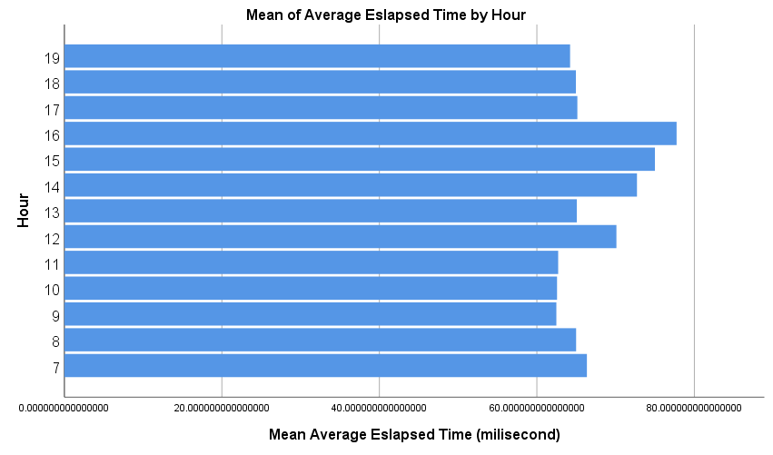

* Chart Builder.
GGRAPH
/GRAPHDATASET NAME="graphdataset" VARIABLES=Hour
MEAN(AverageEslapsedTime)[name="MEAN_AverageEslapsedTime"] MISSING=LISTWISE REPORTMISSING=NO
/GRAPHSPEC SOURCE=INLINE.
BEGIN GPL
SOURCE: s=userSource(id("graphdataset"))
DATA: Hour=col(source(s), name("Hour"), unit.category())
DATA: MEAN_AverageEslapsedTime=col(source(s), name("MEAN_AverageEslapsedTime"))
GUIDE: axis(dim(1), label("Hour"))
GUIDE: axis(dim(2), label("Mean AverageEslapsedTime"))
GUIDE: text.title(label("Simple Bar Mean of AverageEslapsedTime by Hour"))
SCALE: linear(dim(2), include(0))
ELEMENT: interval(position(Hour*MEAN_AverageEslapsedTime), shape.interior(shape.square))
END GPL.

GGraph

Notes
Output Created |  | 12-MAY-2022 16:22:27
Comments
Input | Data | G:\My Drive\0Duy Research Master\Experiments\Exp 1_API\past result\SPSS work\EXP1\AverageEslapsedTime.sav
Input | Active Dataset | DataSet4
Input | Filter | <none>
Input | Weight | <none>
Input | Split File | <none>
Input | N of Rows in Working Data File | 13
Syntax |  | GGRAPH  /GRAPHDATASET NAME="graphdataset" VARIABLES=Hour  MEAN(AverageEslapsedTime)[name="MEAN_AverageEslapsedTime"] MISSING=LISTWISE REPORTMISSING=NO  /GRAPHSPEC SOURCE=INLINE.  BEGIN GPL  SOURCE: s=userSource(id("graphdataset"))  DATA: Hour=col(source(s), name("Hour"), unit.category())  DATA: MEAN_AverageEslapsedTime=col(source(s), name("MEAN_AverageEslapsedTime"))  GUIDE: axis(dim(1), label("Hour"))  GUIDE: axis(dim(2), label("Mean AverageEslapsedTime"))  GUIDE: text.title(label("Simple Bar Mean of AverageEslapsedTime by Hour"))  SCALE: linear(dim(2), include(0))  ELEMENT: interval(position(Hour*MEAN_AverageEslapsedTime), shape.interior(shape.square))  END GPL.
Resources | Processor Time | 00:00:00.16
Resources | Elapsed Time | 00:00:00.12

